**What is Responsive Design?**

Responsive Design means that web pages are created to look good on any device, including large desktop monitors, laptops, tablets, and small-screened smartphones (Pilon, 2018; “HTML Responsive Web Design”, 2018). Traditional web pages may display correctly on a large monitor, but on smaller devices a user may need to scroll horizontally in order to see all of the content. Websites that are graphics heavy might be slow to load and very large images might “break” the layout on smaller devices. With a responsive design approach, a web page has HTML elements and CSS styles which will automatically respond differently when viewed on devices of different sizes, so content is readable and easy to navigate.



(“Responsive Web Design”, 2018)

One way to illustrate responsive design is to compare it directly with a traditional website and Deque Systems has done just this as part of their Web Accessibility curriculum. The following link will take you to a traditional “fixed” web site: <https://dequeuniversity.com/library/responsive/1-non-responsive>

To simulate what this would look like on a tablet or smartphone, squish your browser horizontally, so that content to the right is being cut off and you would need to scroll right to see it.

To see the same website with a responsive design, click the following link:

<https://dequeuniversity.com/library/responsive/1-responsive>

Once again, squish your browser width or view it in a phone or tablet and you should notice that the layout changes and the image becomes narrower.

As part of their curriculum, they provide the code for the responsive web page, which you can find here:

<https://dequeuniversity.com/library/responsive/1-source-responsive>

I am choosing just a few examples of code from their source that are notable.

|  |  |
| --- | --- |
| The viewport is the same as the device width. This makes it so that content will not run off the right side of the browser window. | <meta name="viewport" content="width=device-width, initial-scale=1"> |
| Images will only ever be as wide as the browser window and they will retain the same aspect ratio. | img {  max-width:100%;  height:auto;   } |
| Different nav links were created for desktops, tablets, and phones  Notice that tablet has a single word per list item to make the nav bar narrower. | <li class="desktop"><a href="#">Learn about Accessibility</a></li>  <li class="desktop"><a href="#"> Testing Tools</a></li>  ...  <li class="tablet"><a href="#">Learn </a></li>  <li class="tablet"><a href="#">Tools</a></li>  ...  <li class="phone"><a href="#">Learn about Accessibility</a></li>  <li class="phone"><a href="#"> Testing Tools</a></li> ... |
| When a phone is detected the nav menu is stacked instead of  horizontal. | nav li.phone {  display:block; |

**Why is the mobile web the most important element of web design?**

More and more people are viewing web pages on mobile devices. “A recent Pew study 77 % of Americans now own smartphones in 2018 which is up from just 35% in Pew Research Center’s first smartphone ownership survey carried out in 2011.” More importantly, mobile traffic on websites is growing. The following graph comes from a study of mobile versus desktop usage (Enge, April 27, 2018) and shows that website traffic via mobile devices is on the rise, whereas the total percentage of traffic from desktops in declining.

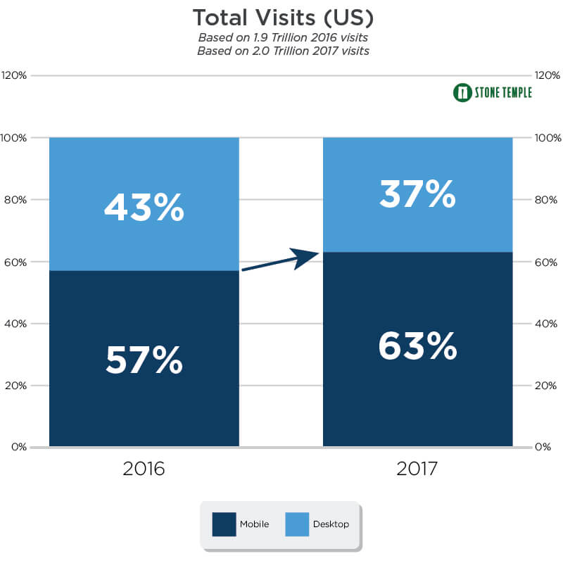

(Enge, April 27, 2018)

Not only does web traffic trends support the idea that mobile web is the most important element of web design, but website developers also need to be mindful of the fact that Google announced the [mobile-first index](https://smallbiztrends.com/2018/04/mobile-first-index-small-business.html), which will rank websites based optimization for mobile devices. “If your website does not have a responsive layout, has a slow loading speed or poorly designed navigation and content, your ranking is likely to decrease if you don’t optimize your site for mobile before the shift” (Marse, Apr 10, 2018).

**References**

Enge, E. (April 27, 2018). “Mobile vs Desktop Usage in 2018: Mobile takes the lead”. Stone Temple. Retrieved from <https://www.stonetemple.com/mobile-vs-desktop-usage-study/>

“HTML Responsive Web Design”, (2018). W3schools. Retrieved from <https://www.w3schools.com/html/html_responsive.asp>

Marse, A. (Apr 10, 2018). “4 Steps to get Your Small Business Website Ready for Mobile First Index”. Small Business Trends. Retrieved from <https://smallbiztrends.com/2018/04/mobile-first-index-small-business.html>

Pilon, A. (May 22, 2018). “What is Responsive Web Design?” Small Business Trends. Retrieved from <https://smallbiztrends.com/2013/05/what-is-responsive-web-design.html>

“Responsive Design Example 1: A 2-column design with header and footer” (2018). Deque University. Retrieved from <https://dequeuniversity.com/library/responsive/1>

“Responsive Web Design” (2018). Tinzi Marketing. Retrieved from <https://tinzi.com/web-design/responsive-web-design/>